**MID - TERM III EXAMINATIONS, 2024**

**MIDDLE CLASS – ENGLISH**

**Name: ………………………………………………Stream: ………………..**

**1. Match pictures to words.**

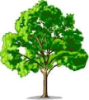

pencil

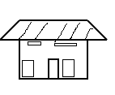

book

house

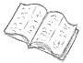

tree

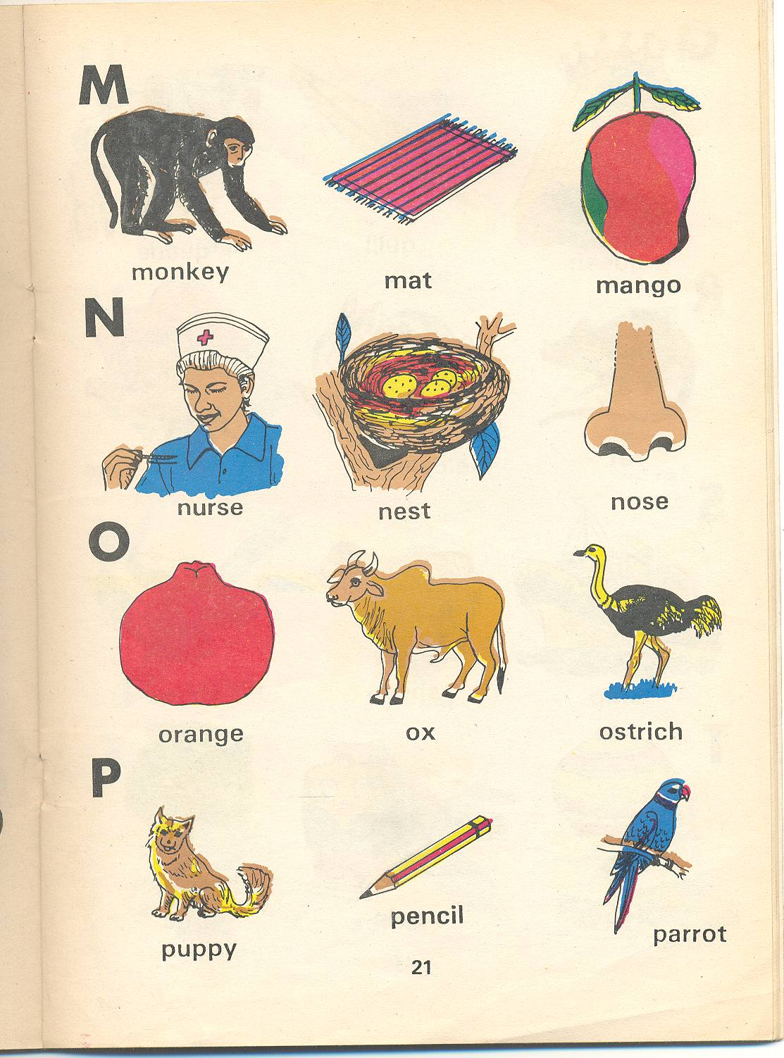

moon

(10mks)

**2. Name these pictures.**

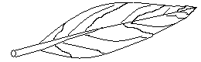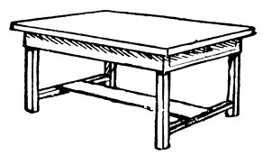

....................... ...........................



....................... .............................

....................... (10mks)

**(flower, table, leaf, stool, drum)**

**3. Write a word for a number.**

stone woman bus pen door

**4 1 3 5 2**

4 .......................... 3 ...........................

5 .......................... 1 ...........................

2 .......................... (10mks)

**4. Cross the same words.**

cat box cat

_______________________________________________

tree tree axe

_______________________________________________

stone pencil pencil

_______________________________________________

bag bag chair

________________________________________________

cup duck cup

_______________________________________________

(20mks)

**5. Complete the sentences.**



This is a ...................................



This is a ...................................

This is a ...................................

 This is a ...................................

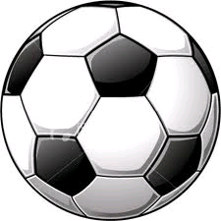

This is a ...................................

**(stick, knife, table, pencil, ball)**

(10mks)

**6. Read and draw.**

|  |  |  |  |  |
| --- | --- | --- | --- | --- |
| **basket** | **star** | **chair** | **broom** | **stone** |
|  |  |  |  |  |

(10mks)

**7. Tick the given word.**

**tree** leaf

cat leaf

tree lorry

**chair book pencil**

church book pen

chair box pencil

(10mks)

**8. Match to the belongings.**



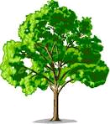









(10mks)

**9. Circle a word for a picture.**

|  |  |
| --- | --- |
|  | **pencil pen** |
|  | **man moon** |
|  | **book box** |
| **C:\Users\Secretary\Documents\OTHERS\new images\Others\keys.bmp** | **kite key** |
|  | **chair car** |

(10mks)